**DAY 3 ASSIGNMENT**

**import** **seaborn** **as** **sns**

**import** **pandas** **as** **pd**

**import** **numpy** **as** **np**

**import** **matplotlib.pyplot** **as** **plt**

%matplotlib inline

fmri=sns.load_dataset('fmri')

fmri.head()

OUTPUT:

subject timepoint event region signal

|  |  |
| --- | --- |
| 0 | s13 18 stim parietal -0.017552 |
| 1 | s5 14 stim parietal -0.080883 |
| 2 | s12 18 stim parietal -0.081033 |
| 3 | s11 18 stim parietal -0.046134 |
| 4 | s10 18 stim parietal -0.037970 |

fmri.info

OUTPUT:

0 s13 18 stim parietal -0.017552

1 s5 14 stim parietal -0.080883

2 s12 18 stim parietal -0.081033

3 s11 18 stim parietal -0.046134

4 s10 18 stim parietal -0.037970

... ... ... ... ... ...

1059 s0 8 cue frontal 0.018165

1060 s13 7 cue frontal -0.029130

1061 s12 7 cue frontal -0.004939

1062 s11 7 cue frontal -0.025367

1063 s0 0 cue parietal -0.006899

sns.relplot(x='timepoint',y='signal',data=fmri)

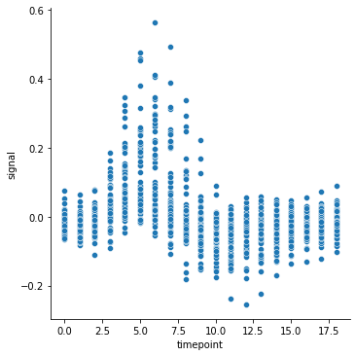

sns.relplot(x='timepoint',y='signal',kind='line',data=fmri)

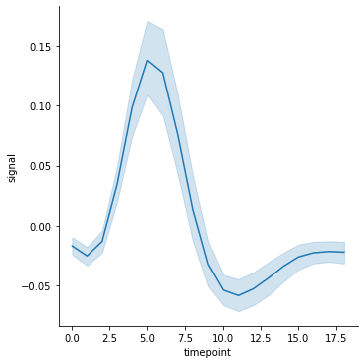

sns.relplot(x='timepoint',y='signal',kind='line',data=fmri,estimator= **None**)

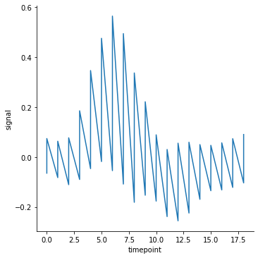

sns.relplot(x='timepoint',y='signal',data=fmri, hue='event',kind='line')

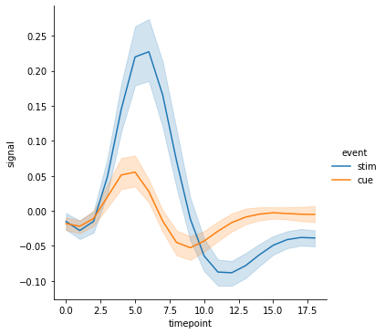

sns.relplot(x='timepoint',y='signal',data=fmri, hue='event',kind='line',style='region')

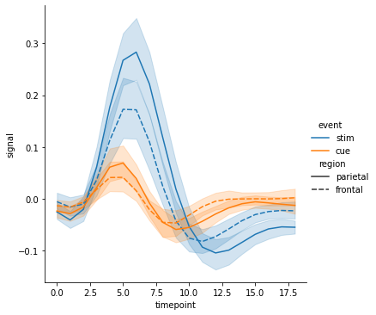

sns.relplot(x='timepoint',y='signal',data=fmri, hue='event',style='region')

